**Guidance Bulletin** 

**No. 2021-02**

**LEAD IN OR EXIT?**

**Safety Zone Tapers**

There has always has been a requirement in the Red Book to install two safety zones one before your works called the **Lead In Taper** and one after called the **Exit Taper**. Both of these form an essential part of the safety zone make up of your works which is designed to provide protection to those working inside the works and act as a guide to vehicle drivers approaching works 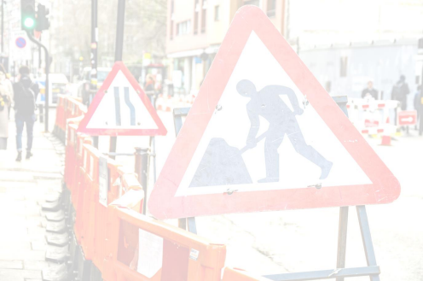

**Lead-in taper**

The **recommended lead-in taper** is given in the table inside the back cover. Sometimes it might not be practicable to provide the full taper. If this happens on congested roads with speed limits of 30 mph or less, shorter lengths of taper may be used. **Reduced tapers should always be as long as permitted under the circumstances**. However, they must not be reduced to less than 45º unless there are restrictions associated with parked vehicles

**Exit taper**

An exit taper is normally required and should be at 45° to the kerb line or road edge. However, for works on a dual carriageway where a works vehicle exit is needed, the exit taper may be omitted as long as the end of the works is properly signed as a works vehicle exit.

**DO** Install the recommended length of lead in taper for the road speed as per the table back of the Red Book (T) **DO** Install the maximum length you can if your risk assessment shows the recommended length cannot be achieved

**DO** Consider the option to reduce the lead in taper to 45º on a 30mph road if the full length cannot be achieved. **DO** consult with the Highway Authority if the lead in Taper is going to interfere with bus stops, pedestrian crossings,

junctions, roundabouts or level crossings

**DON’T** Start work until all the safety zones have been established including the tapers and sideways safety zones. **DON’T** Reduce the length of the lead in taper without completing a risk assessment to justify its reduction**.**

**\*HAUC(UK) thanks Morrison Water Services in their help in the creation of this guidance. **

**This information is general guidance only and is not intended to replace specific legal advice. None of HAUC(UK) or its members, accept any liability for any action or omission taken based on this guidance.**